How to run Spring Boot Application With Maven :

1. Click Run/Debug Configuration
2. Add maven
3. Configure Maven as below image :

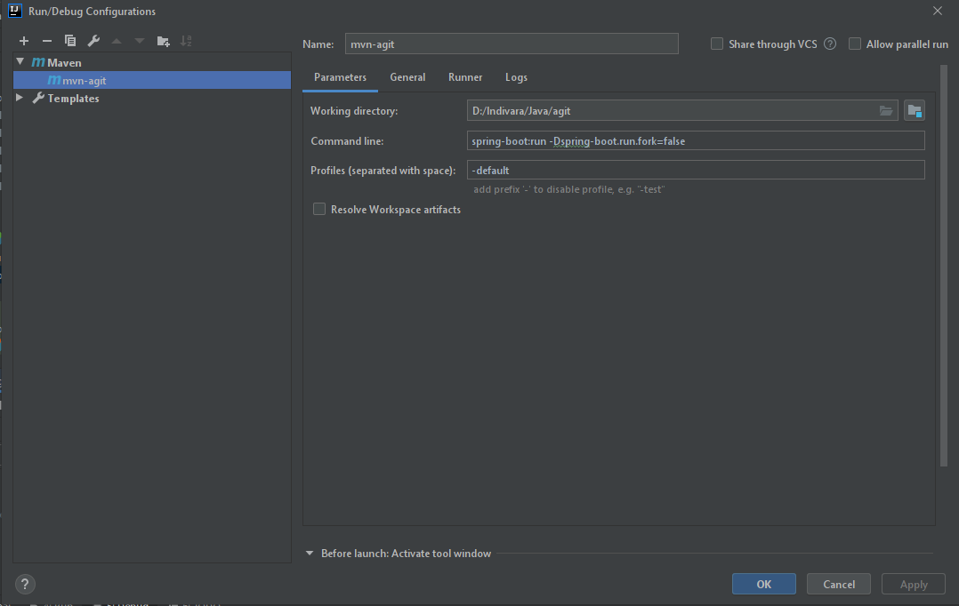

Command Line : spring-boot:run -Dspring-boot.run.fork=false

Profiles : -default

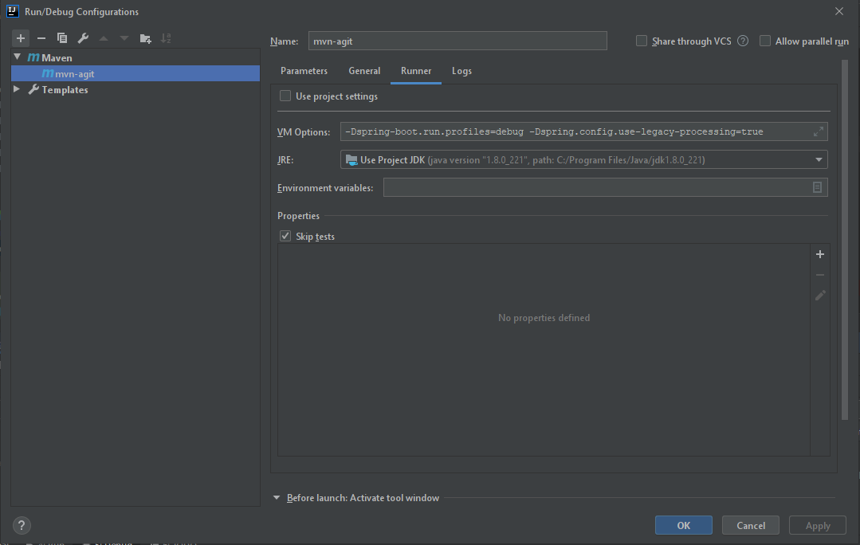

VM Options : -Dspring-boot.run.profiles=debug -Dspring.config.use-legacy-processing=true